Nguyễn An Phúc – 21IT639

Lab 3 _ Creating Users+ Groups

16.2 Creating Groups
Step 1 -> 6
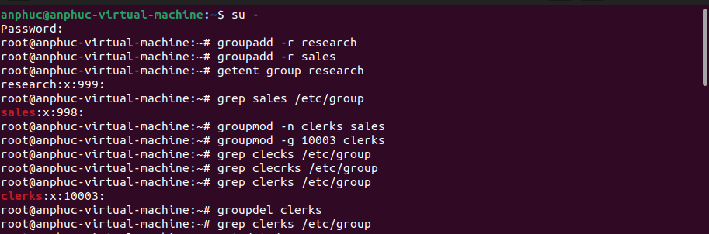
16.3 User Configuration
Step 1 – 2
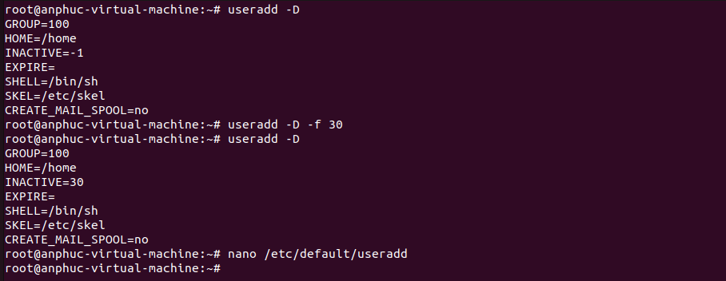
Step 3 - 5
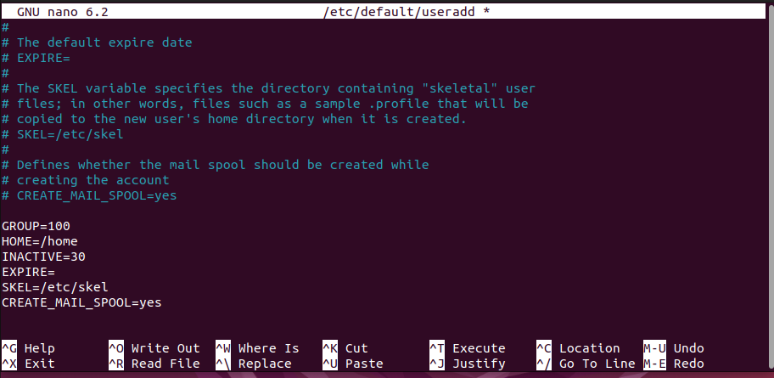
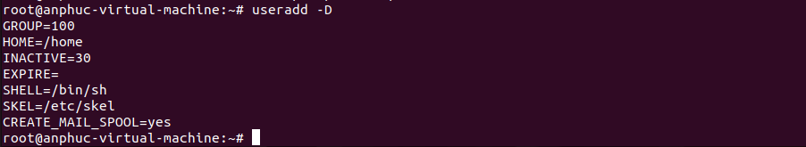
Step 6 – 8
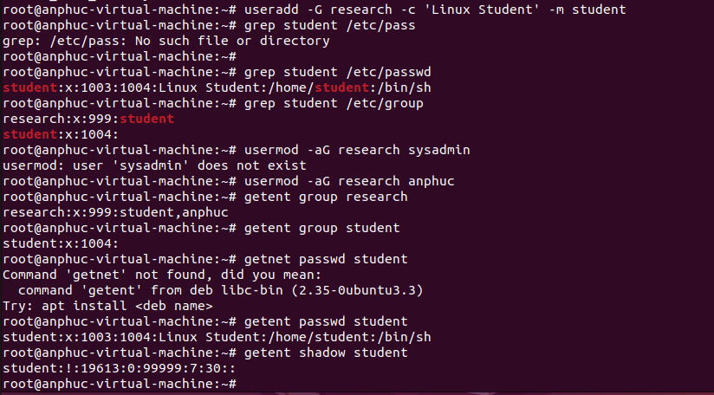
Step 9
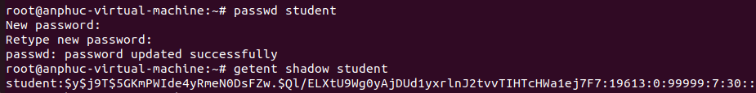
Step 10
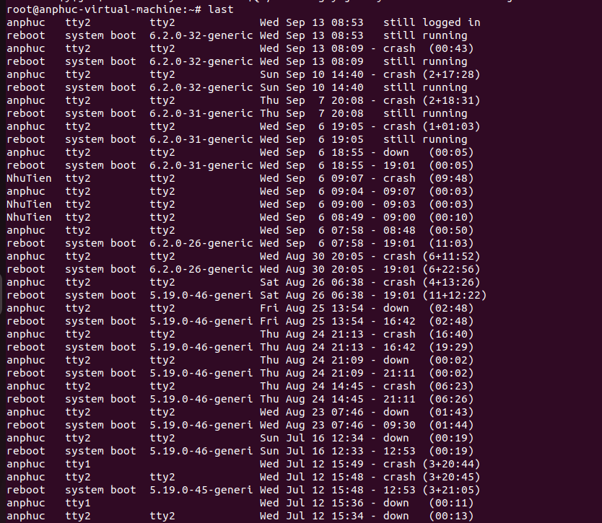
Step 11

